What is VPC?

Think of VPC as the virtual data center in the cloud.

VPC – AWS Definition

Amazon Virtual Private Network lets you provision a logically isolated section of the AWS Cloud where you can launch AWS resources in a virtual network you define. You have complete control over the virtual networking environment, including selection of your own IP address range, creation of subnets, and configuration of route tables and network gateways.

We can have multiple VPCs in a region. The soft limit is 5 which can be increased.

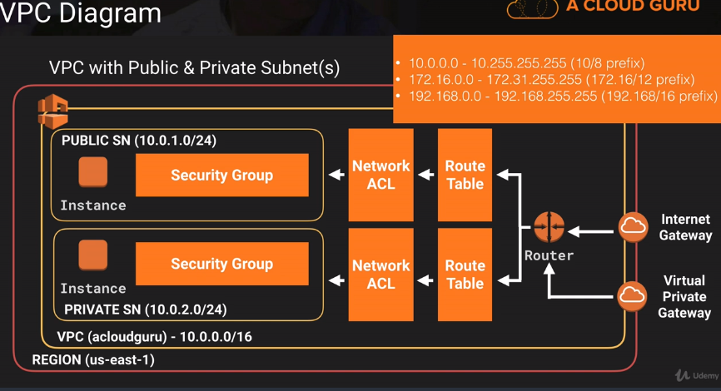

1subnet is equivalent to 1 AZ.

CIDR.xyz website to find the subnet value.

What can you do with a VPC?

1. Launch instances in the subnet of your choice.
2. Assign custom IP address ranges in each subnet.
3. Configure route tables between subnets.
4. Create internet gateways and attach it to our VPC.
5. Much better security control over your AWS resources.
6. Instance security groups.
7. Subnet network access control lists(ACLs).

Default VPC vs Custom VPC

1. Default VPC is user friendly, allowing you to immediately deploy instances.
2. All Subnets in default VPC have a route out to the internet.
3. Each EC2 instance has both a public and private IP address.

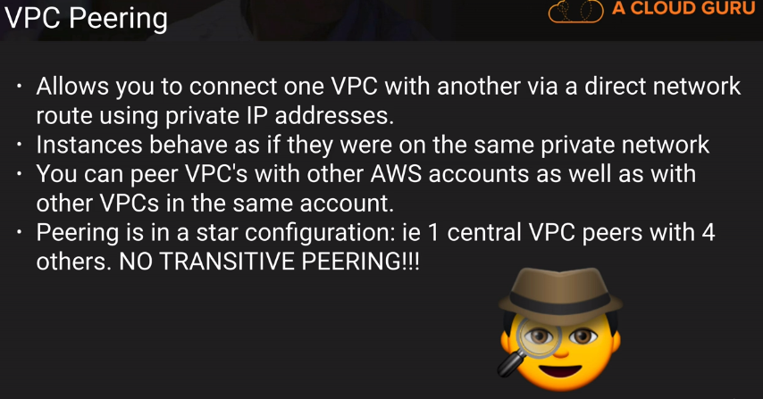

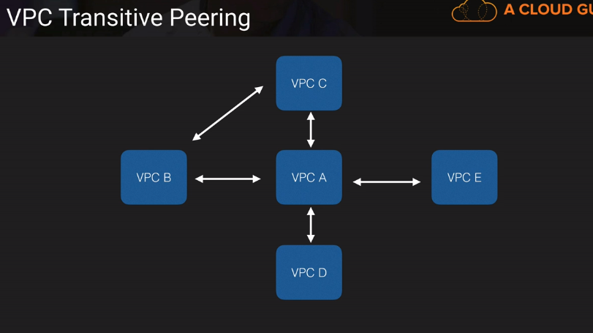

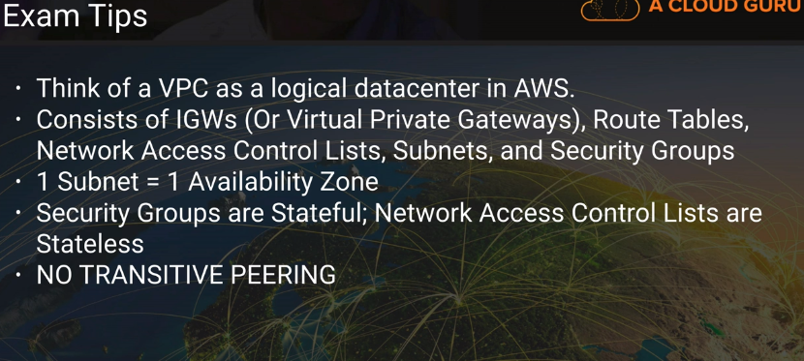

VPC Lab part 1-

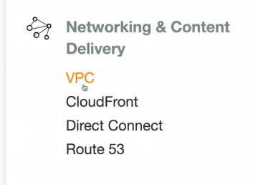

Default VPC, Subnets, IGW, Route table are below,

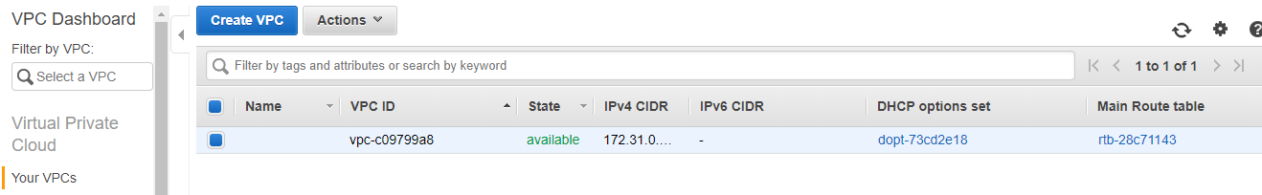

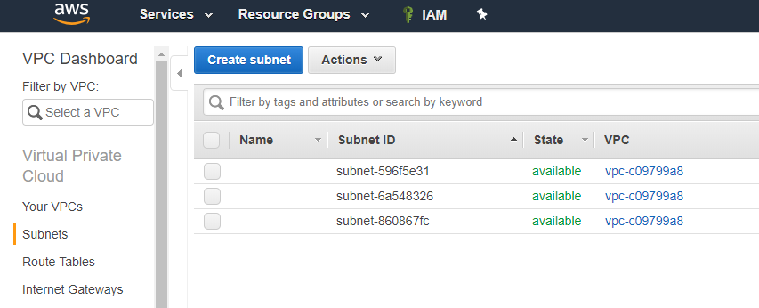

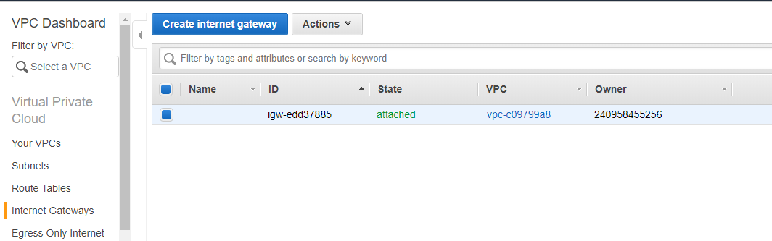

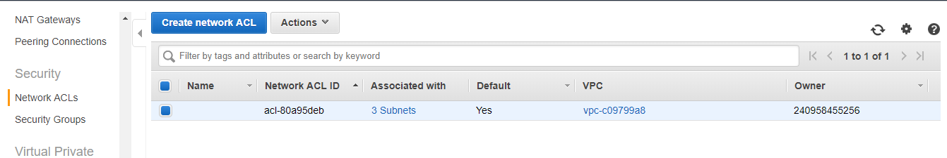

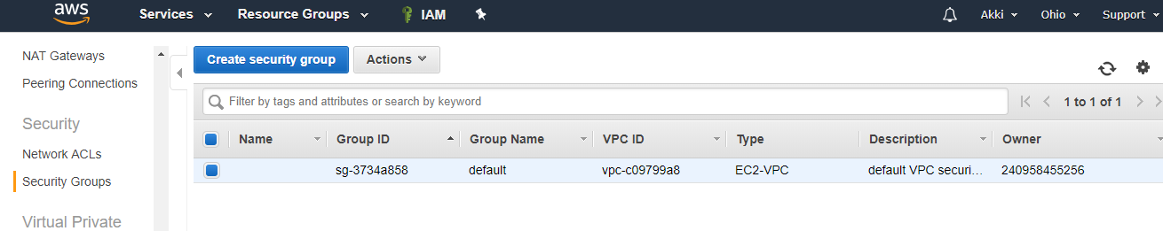

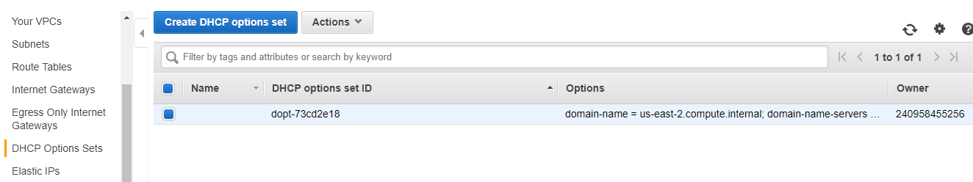

Creating a new VPC,

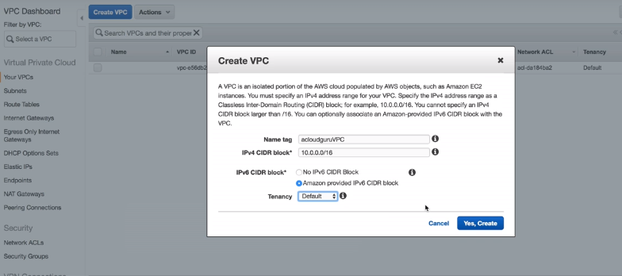

Tenancy 2 options-

Default

Dedicated – the hardware will be dedicated, cost will be high.

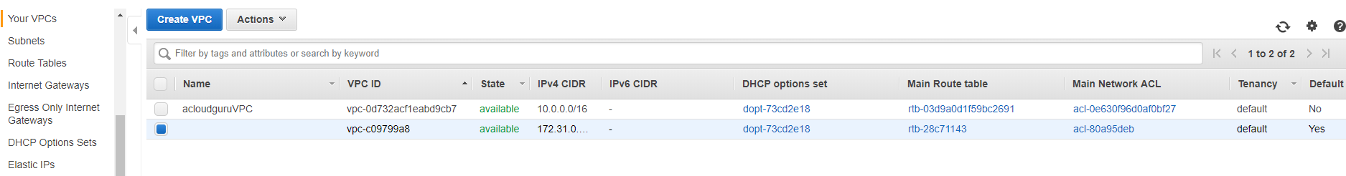

When you create a VPC, the below will be created by default,

SG, Network ACL, Route Table

Subnets and internet gateways are not created.

So far the below has been created,

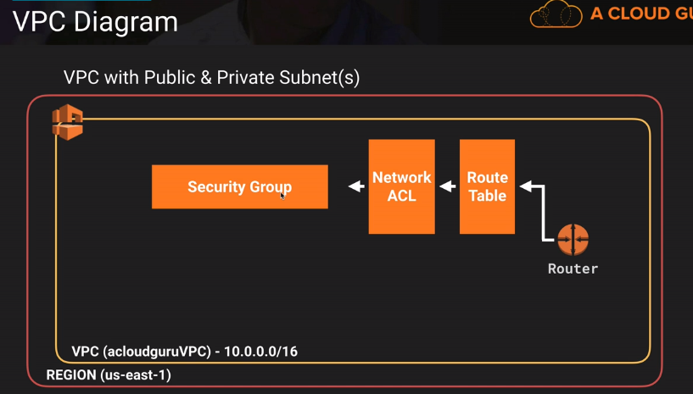

Create subnets,

(Us-east-1a is not same on every account, only the name remains the same. So, the us-east1a on my account can be completely different on my account than your account only the name remains the same.)

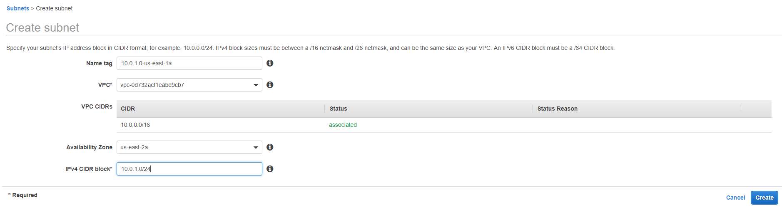

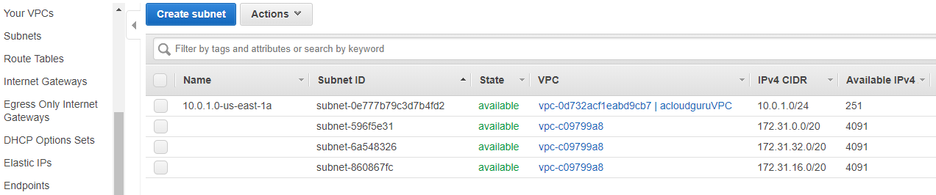

The available IP address here is 251 which should have been 256(2 power 8).

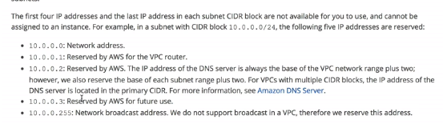

Two subnets are created,

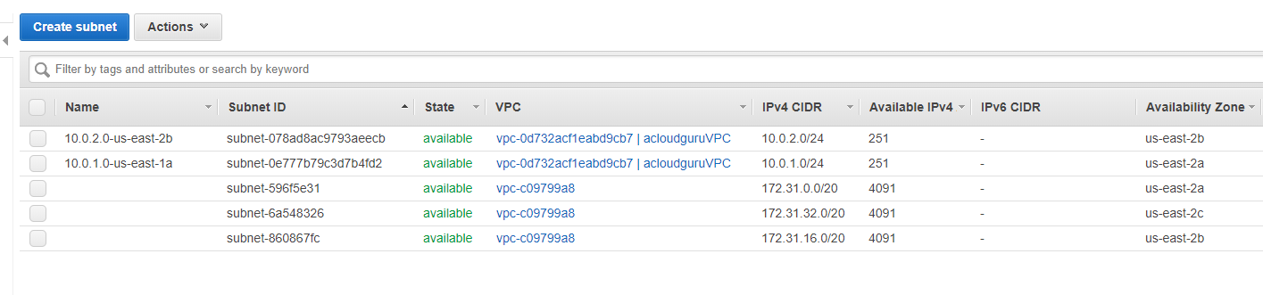

Currently, our VPC look like the below,

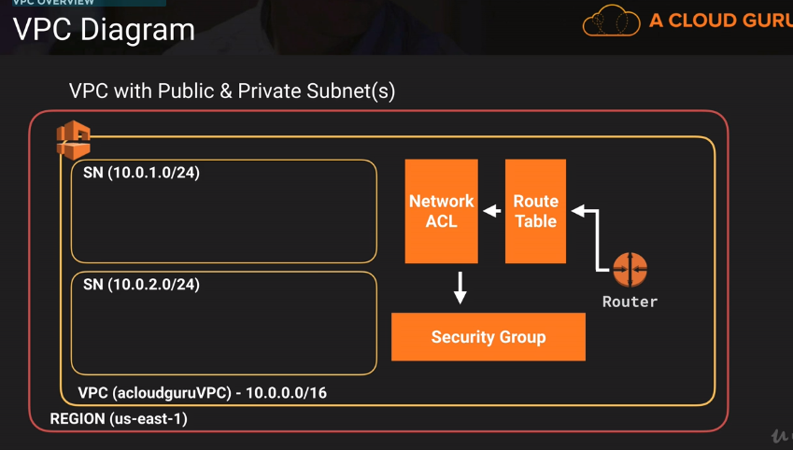

We need to add internet gateway to provide internet connectivity.

Create an IGW and attach it to the VPC,

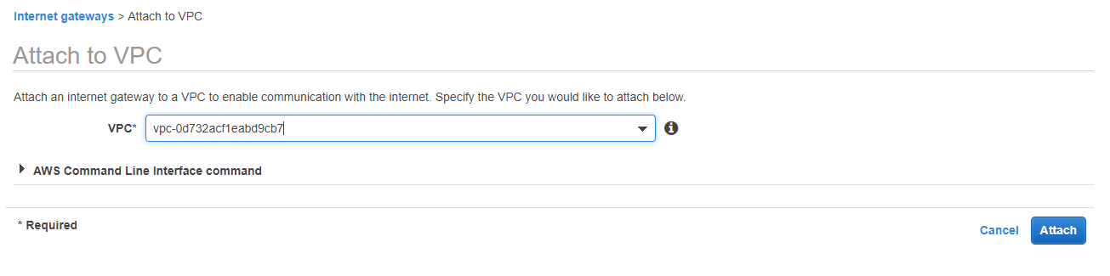

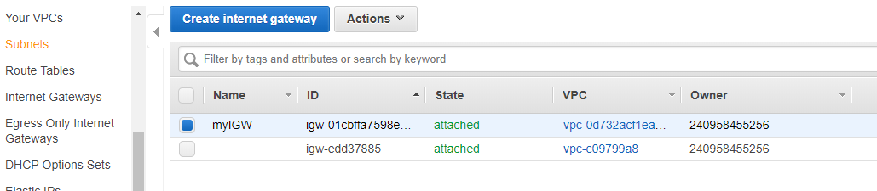

**You cannot have multiple IGW on a VPC.

We will not assign the IGW on the default route table created after VPC creation as this will make all the subnets created in the VPC public. So, we will create a new route table and assign the IGW to it.

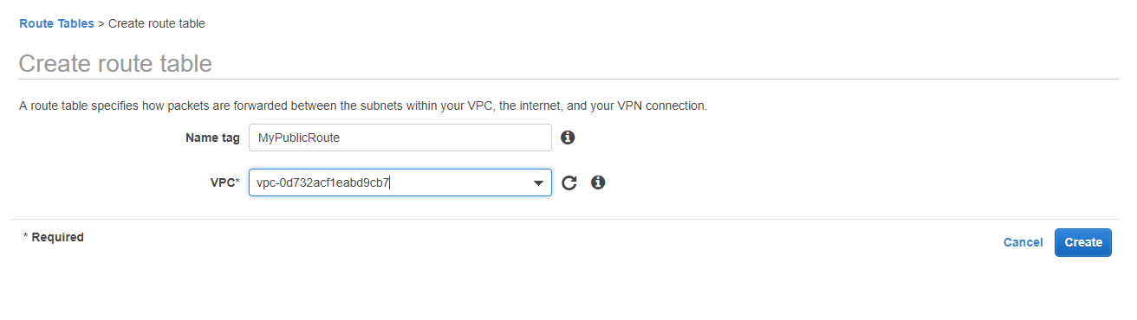

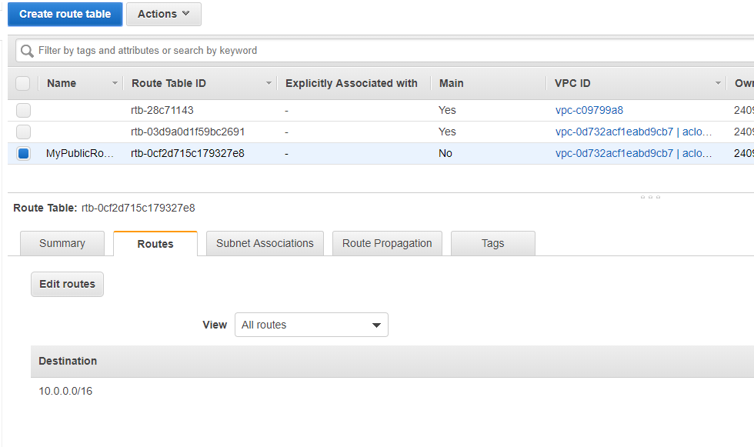

Add IGW to it,

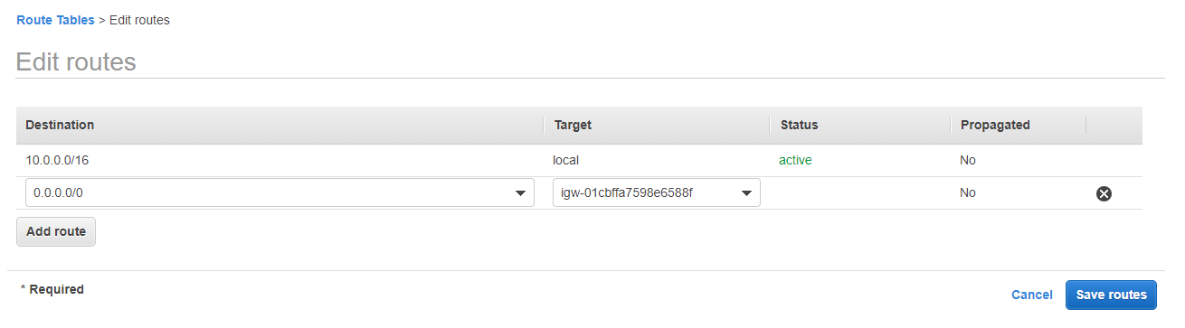

0.0.0.0/0 will make all the traffic on this VPC targeted to the IGW created. So any subnets associated to it will be public.

The auto-assign public IP address will be NO by default for the subnets which we created.

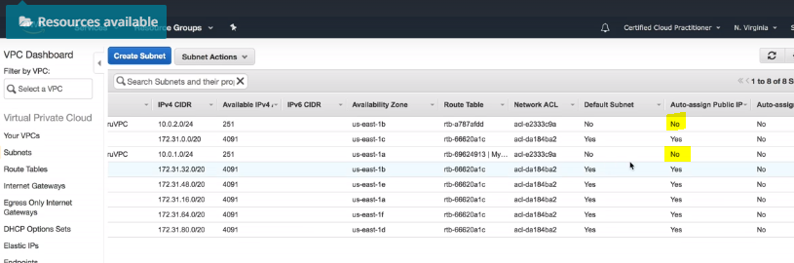

But we want to assign the public IP address to the subnet we want to make public otherwise we will not be able to access the EC2 instance running on it.

Select the subnet for which we need the public IP address and go the actions and select enable auto-assign IP settings and enable it and save.

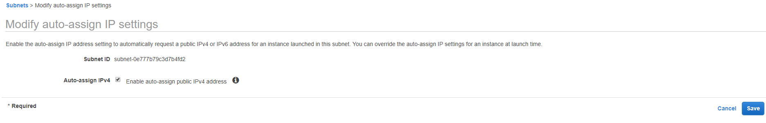

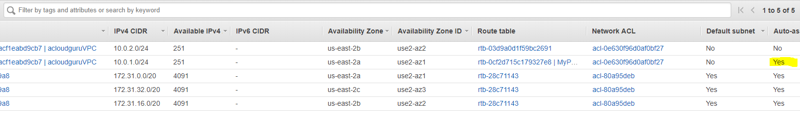

We are ready to launch our EC2 instance on it.

Services->EC2

EC2 configure settings,

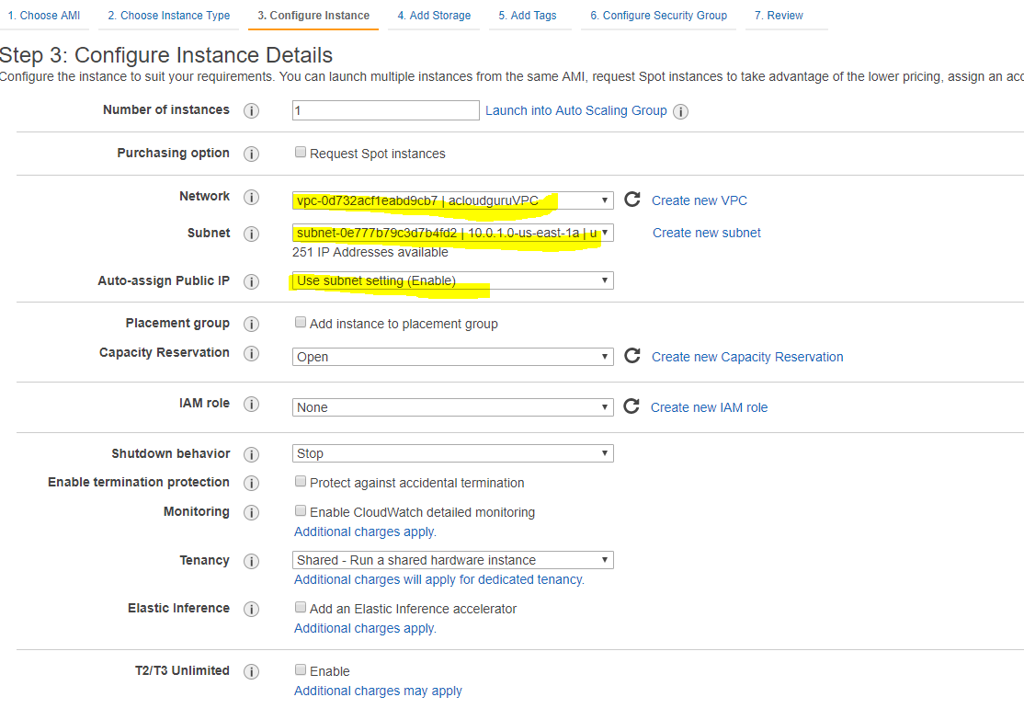

**Security Groups do not span VPC, they exist in the VPC you created.

Launch another instance which is in private subnet.

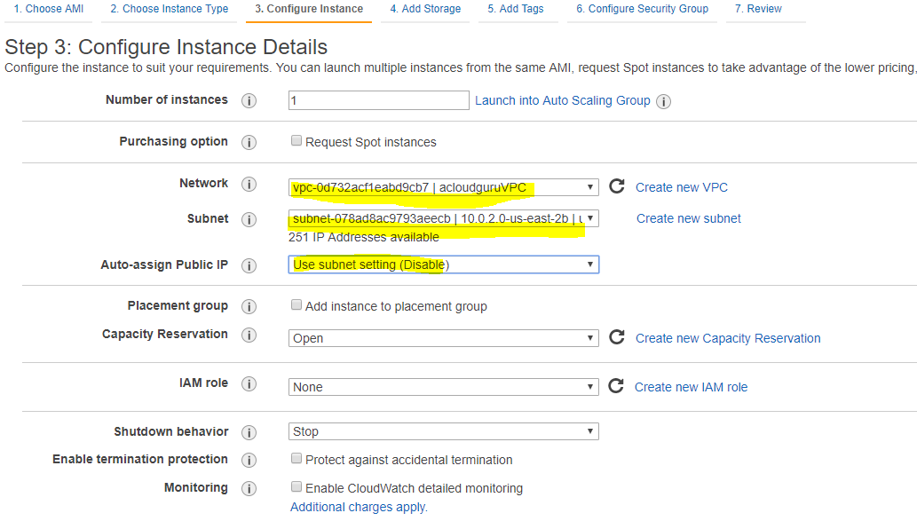

Choose default SG as we do not want it to be open to the world unlike the public webserver where the SG was newly created specifying the inbound rules.

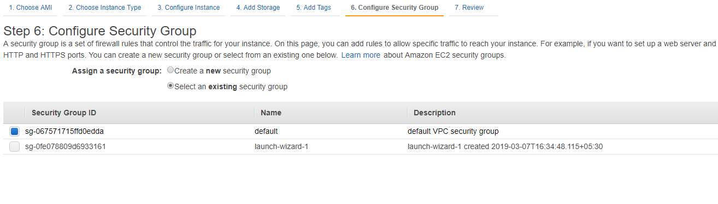

Both the instances are created, both in different AZs. One has the public IP and the other do not have it.

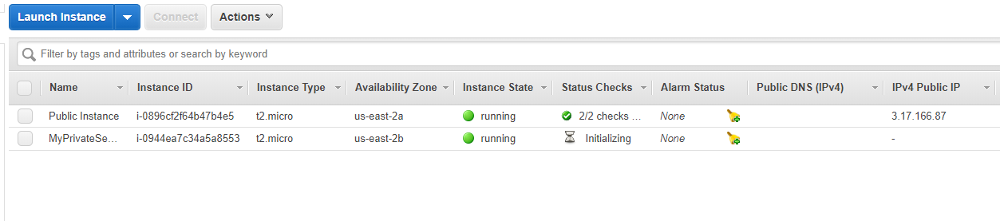

The below is created so far,

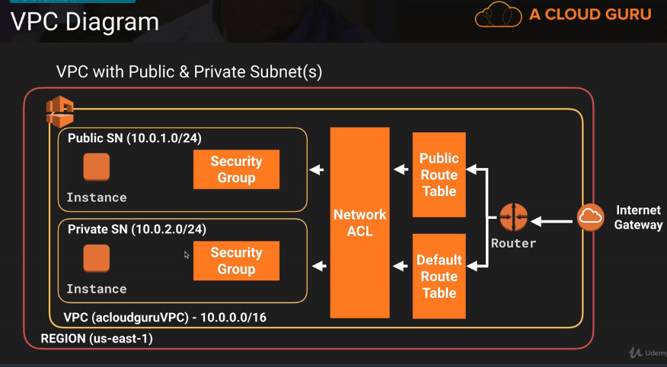

The two instances in the two different subnets will not be able to communicate to each other so far.

In the Private WebServer , we will host the database server. For this we will create a new SG with following inbound rules.

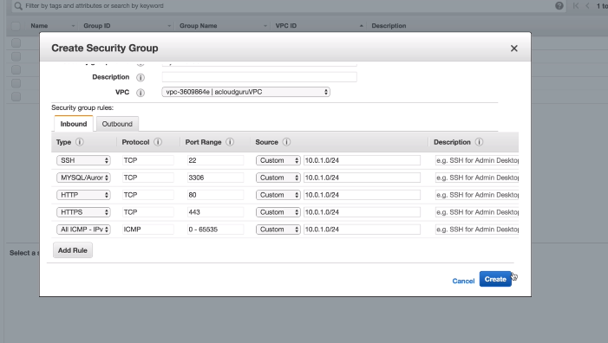

The CIDR will be that of the public subnet as we will try to access the private Instance from that of the public subnet.

All ICMP inbound rule wil allow us to connect from the public instance to the private instance.

Change the SG for the private Instance,

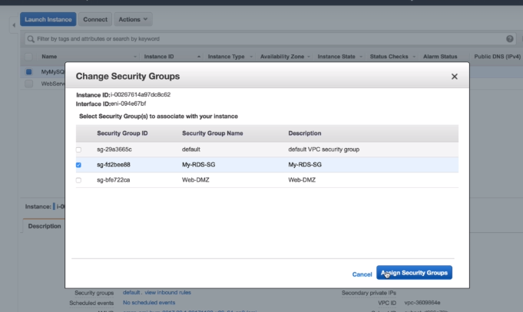

SSH to our public instance and try to ping the private IP address of the private instance.

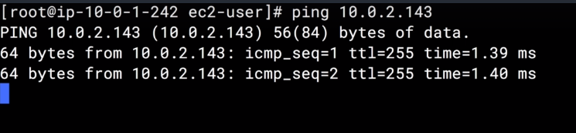

Since we are able to communicate to our private network from the public network, we can connect to the private network from the public instance running. Copy the private key in a notepad in the public instance as it is needed for the connection.

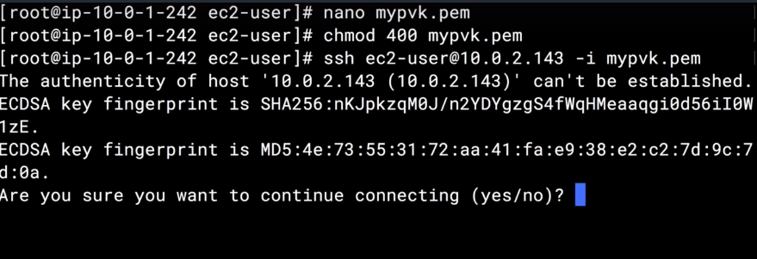

The private subnet has no internet connection so if we try the below command,

Yum update -y

It will timeout as no internet connectivity.

How to have the internet connectivity in the instances running in the private subnet without moving it to the public subnet?

NAT Instances and NAT Gateway

We will have to launch a NAT Instance,

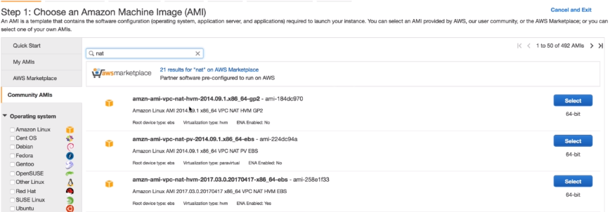

Configure the subnet and network in the instance details,

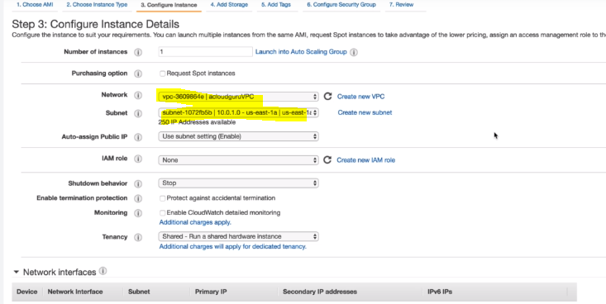

Select the already created SG, it should have HTTPS, HTTP and SSH inbound rule.

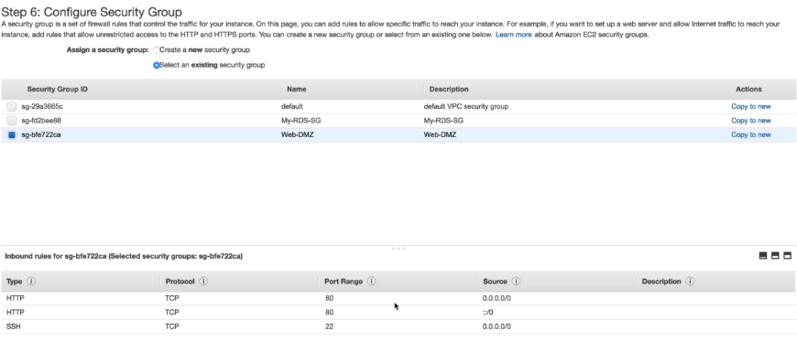

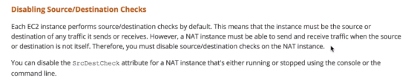

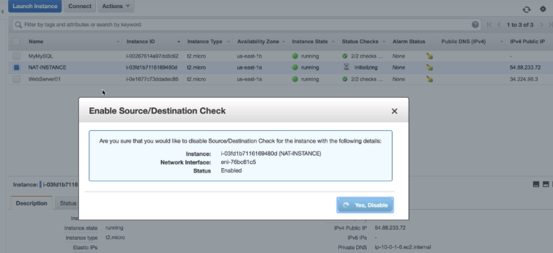

Now we need to go to the VPC and edit the route table and add the route for the NAT instance in the default root created for this VPC.

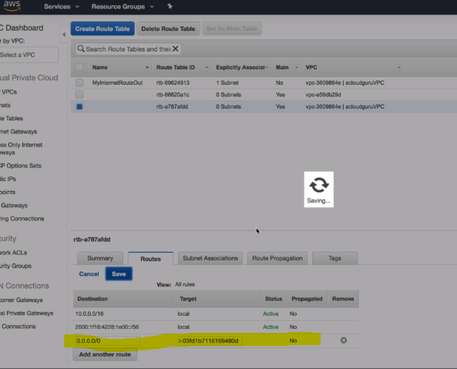

SSh to ur public instance then from there ssh to ur private instance.

Now type the below command to check if we have the internet access in the private instance as well as we have now added the route to the VPC for NAT Instance.

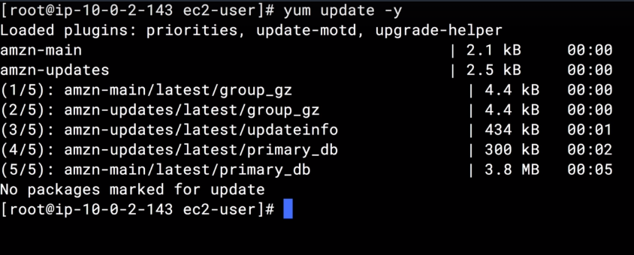

We will do the same using NAT gateway now. So lets terminate the NAT Instance 1st.

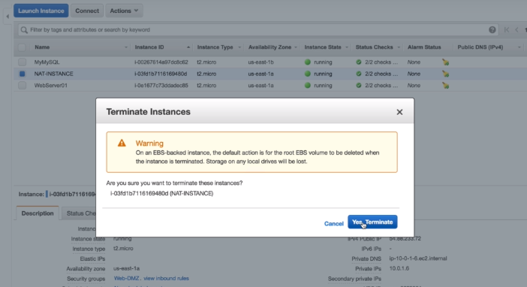

Now go to your Private(MYSQL) instance and install SQL.

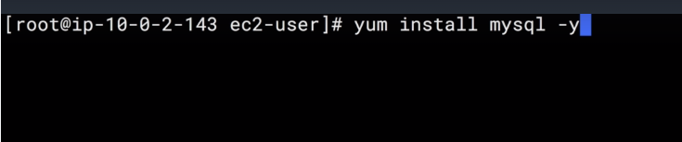

You will get all kinds of errors as there are no route out to the internet right now.

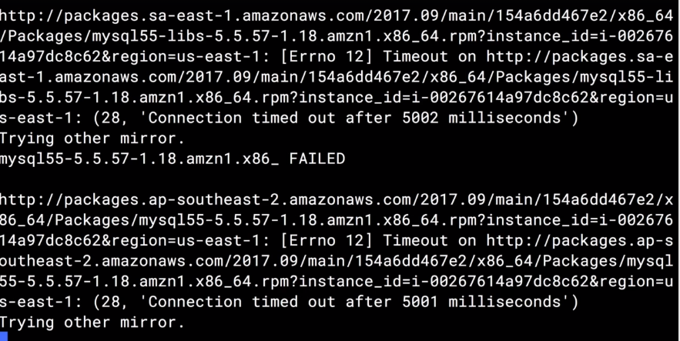

Open VPC service and Create NAT Gateway,

Make sure you select the public subnet and create new EIP.

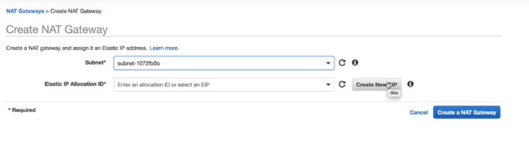

It takes 10-15 mins to make it available.

Go to route table and edit the default route table to add the NAT gateway. So that the traffic can be routed to the external network.

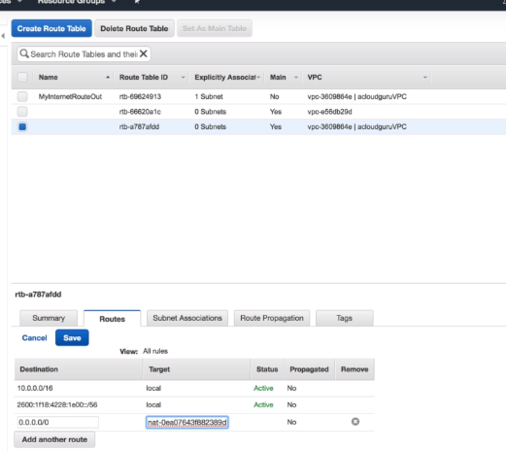

Again ssh to the private network through the public network and try to access internet as below,

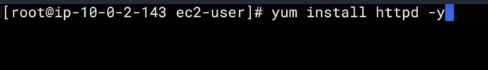

It will complete successfully.

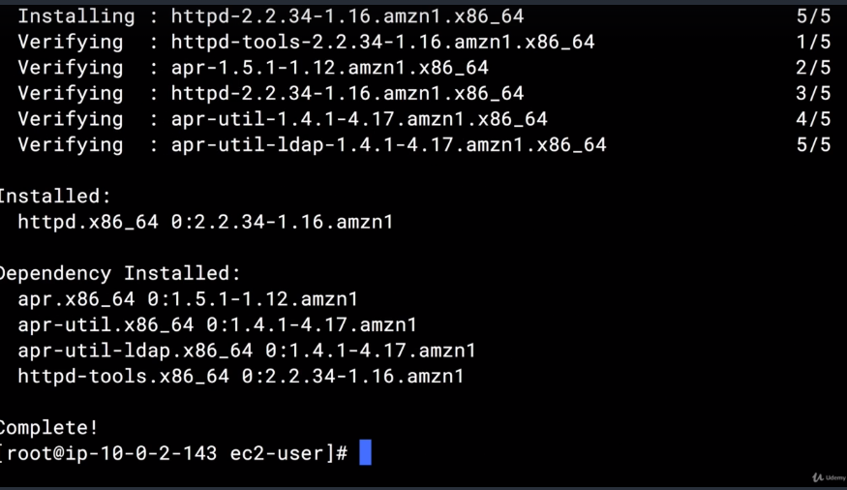

Comparison between NAT Gateway and NAT Instance.(Google)

NAT Instances are pain to manage. NAT gateway is easy to use. No issues in the failover like that of the instance. We do not have to worry about the patching or the upgrade like that of the instance. Gateway is managed by AWS.

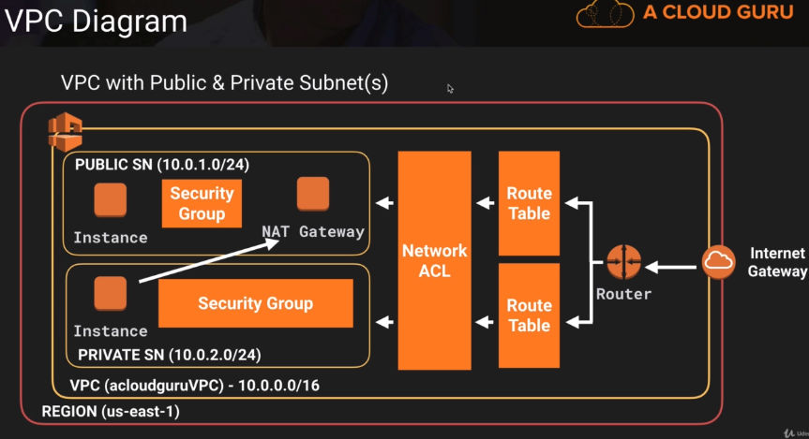

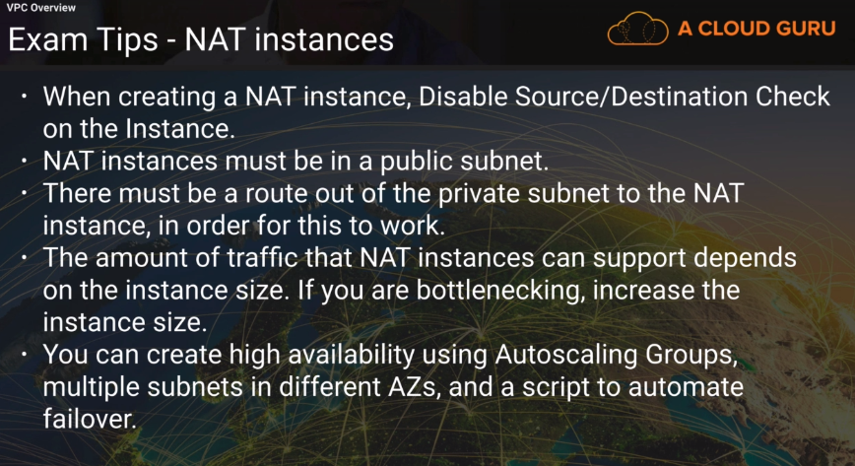

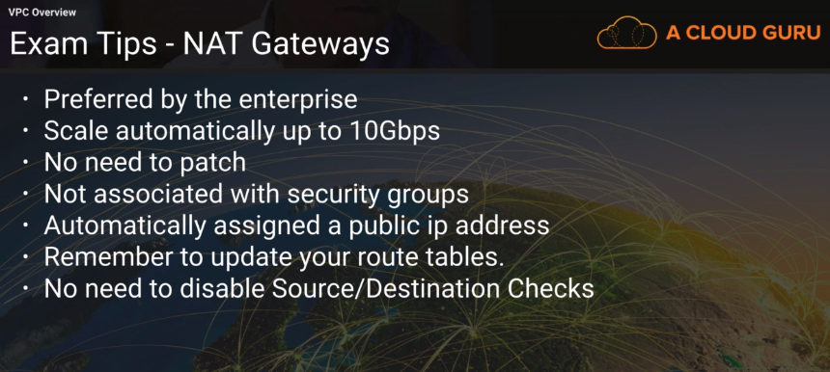

**Network Access Control lists vs Security Groups**

**You can have your subnet associated with only one NACL.

The default NACL will have the created subnets associated with it in a VPC. And it will allow all the inbound and outbound traffic(open to the world).

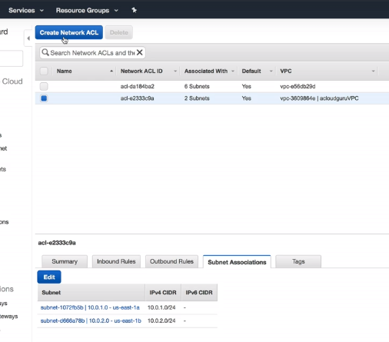

**The Rules are in increment of 100 for IPV4 and 101 for IPV6. The rules are evaluated in the order of rule #.

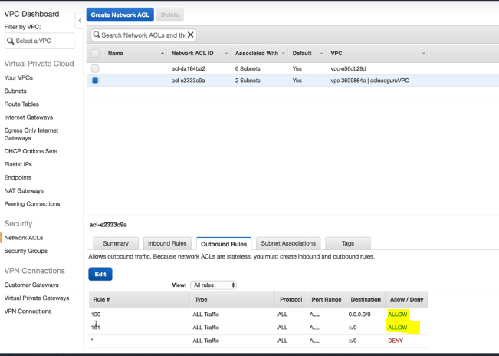

Create a new NACL by giving name and selecting the VPC.

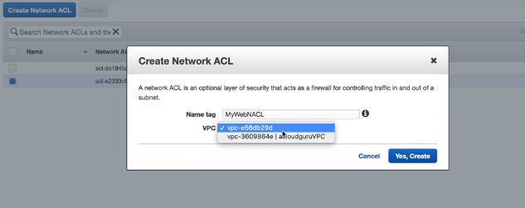

**It will not be open to the world. It will have deny for both inbound and outbound traffic.

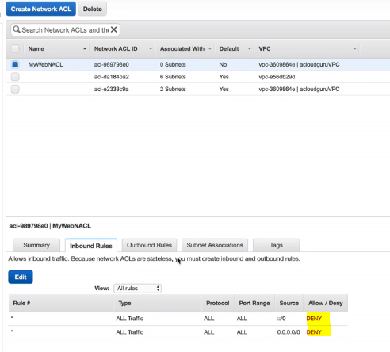

To test it, ssh to your public webserver and install the apache and host a webpage.

Test it on the web browser using the public IP.



Now , we are all set to customize our network ACL.

Go to the VPC service, Select the NACL created and edit the inbound rule to allow the below. Always start with rule 100 for IPV4 and go up with the increments of 100.

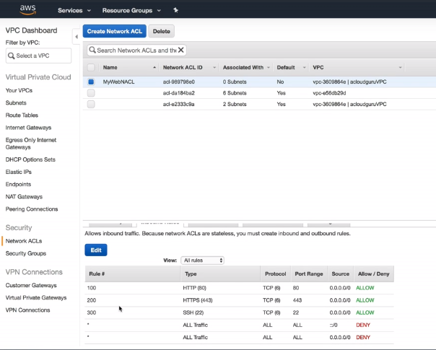

For SG when we edit the inbound rule, it will allow both Inbound and outbound rules automatically. But for NACL we have to edit both inbound and outbound explicitly.

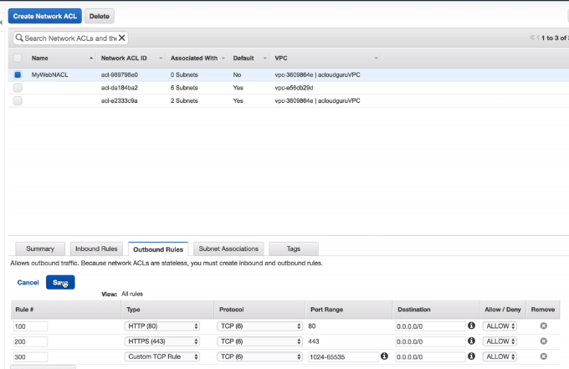

For custom TCP, the port range is ephemeral port.

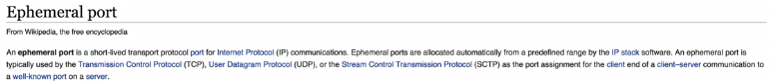

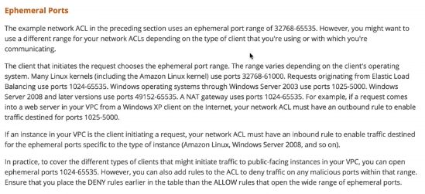

The response for the HTTP request can be returned to any port number so to overcome this we use ephemeral port.

Now associate your created NACL with the public subnet.

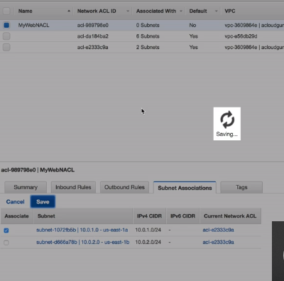

The subnet can be associated with only one ACL, so after associating with the new NACL, the public subnet will not be associated with the default subnet.

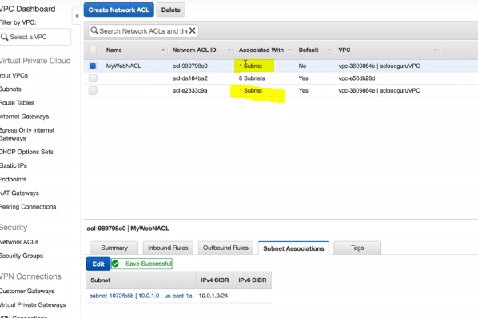

Lets check it that works. Refresh ur browser and check if that works.

And it should work.

Now go back to VPC -> NACL and edit the inbound rule of the NACL associated with the public subnet to deny your IP address.

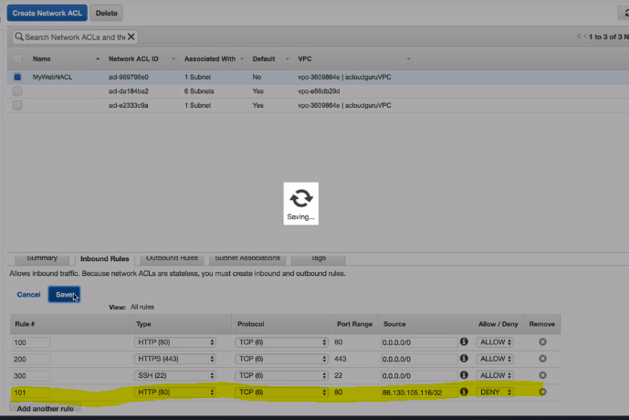

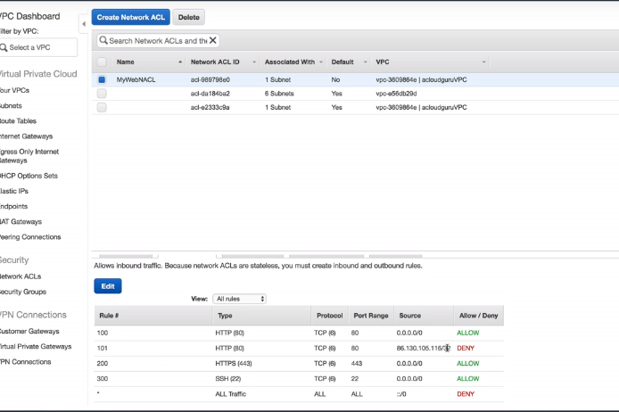

Again refresh the page, there will be no change in the web page as the rules are evaluated in numerical order(100 comes before 101).



Now lets move this rule to 99. It should now dent HTTP and you will get timeout after hitting the URL.

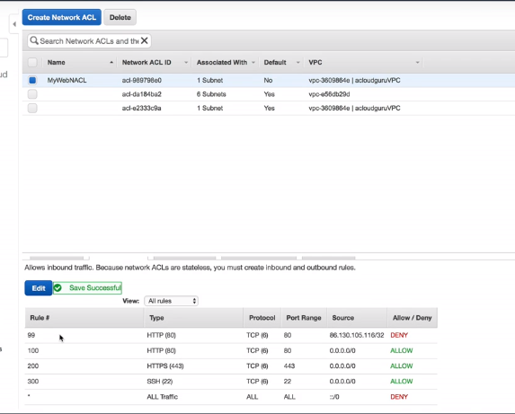

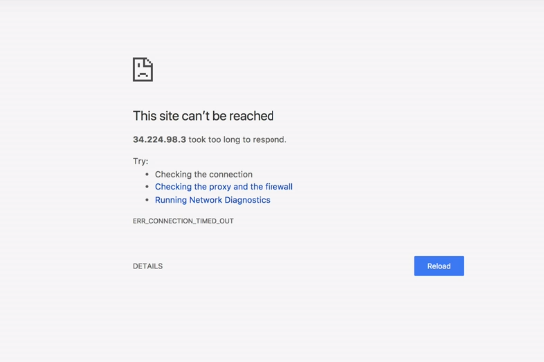

With NACL you allow or deny any IP address.

NACL are evaluated before Security Groups.

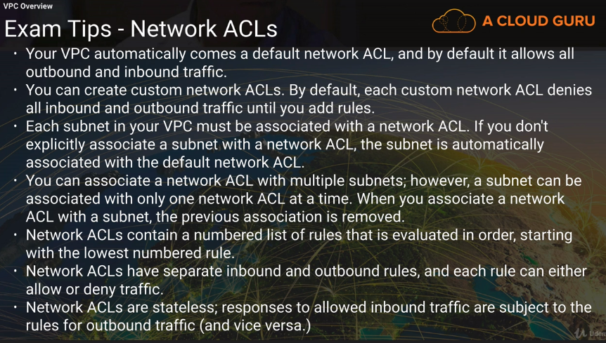

Load Balancers and VPC-

Go to VPC -> Load Balancers -> Create Load Balancer

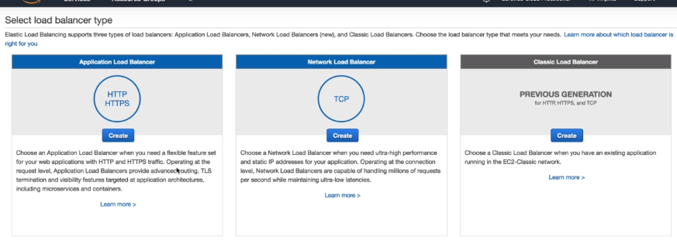

Select from the 3 different types of Load Balancers -> Application LB

*The Application load balancer configuration need to have two subnets in two AZ and bot should be public.

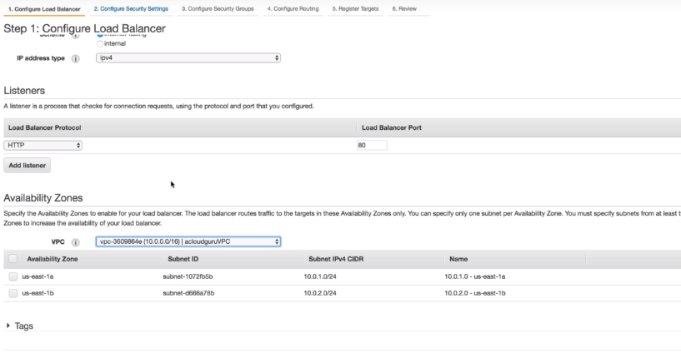

VPC Flow Logs- It is the way of tracking network traffic to and fro your eni(elastic network interface – entry point for your network. It is attached to the ec2 instances).

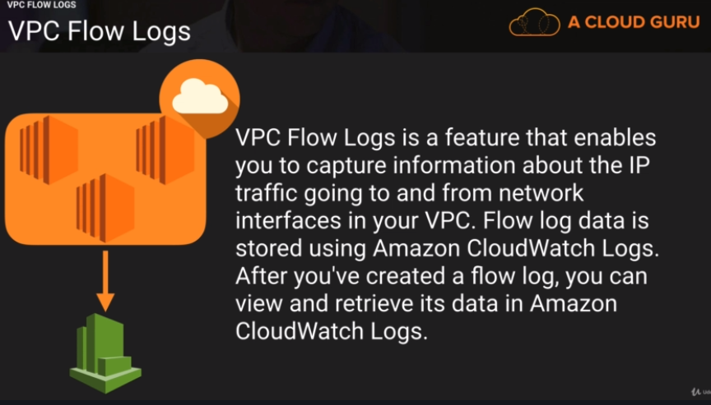

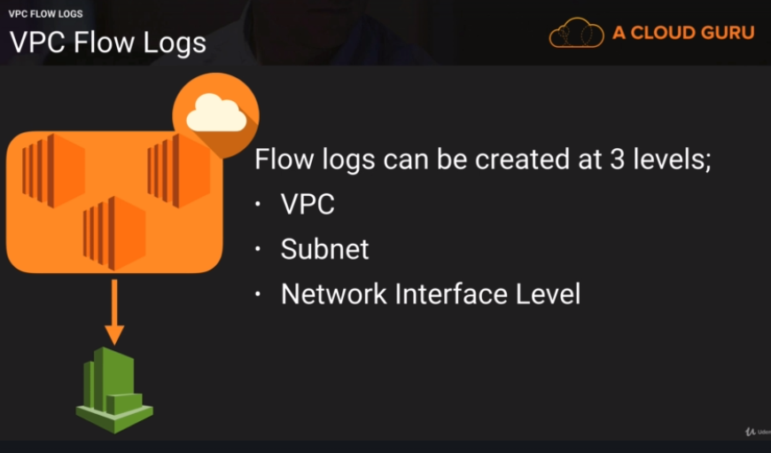

LAB –

Go to cloud watch and create new log group to be used in flog log in VPC.

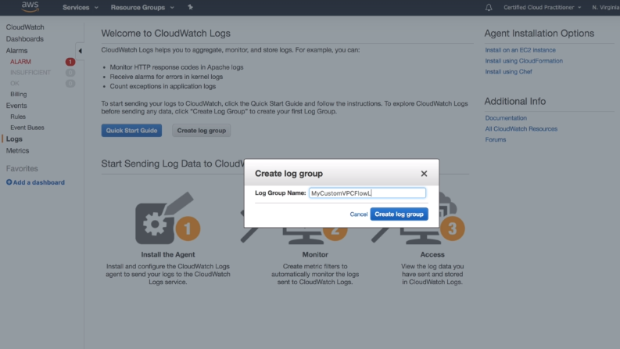

Go to VPC service -> select the already created VPC -> Actions ->Create flow log

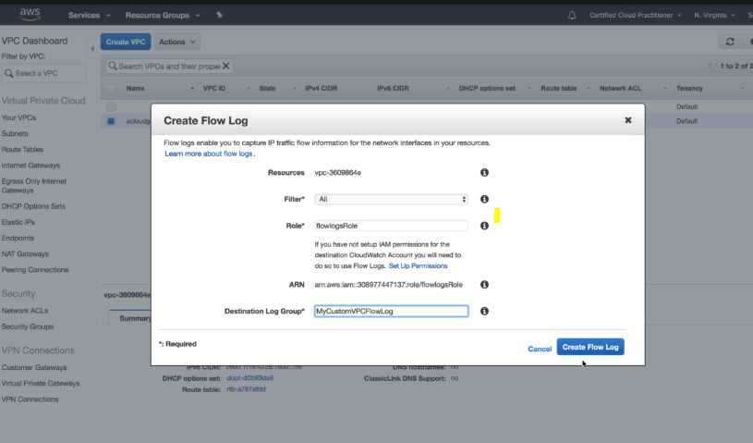

Create the new IAM role in the drop down of Role and select the destination log group which we have already created.

Go back to the cloud watch and see the logs. We can steam these logs to lambda for your environment to proactively react for something happening in the VPC.

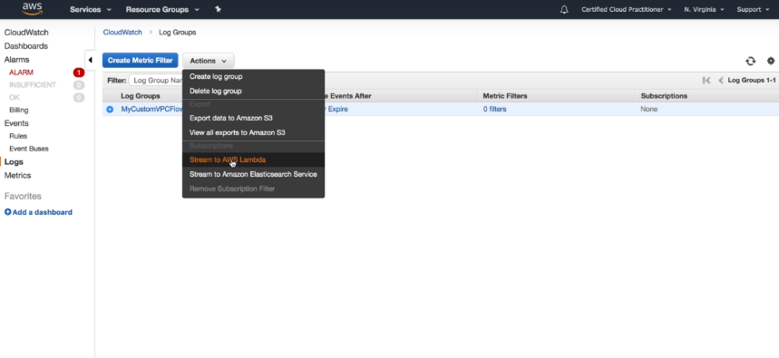

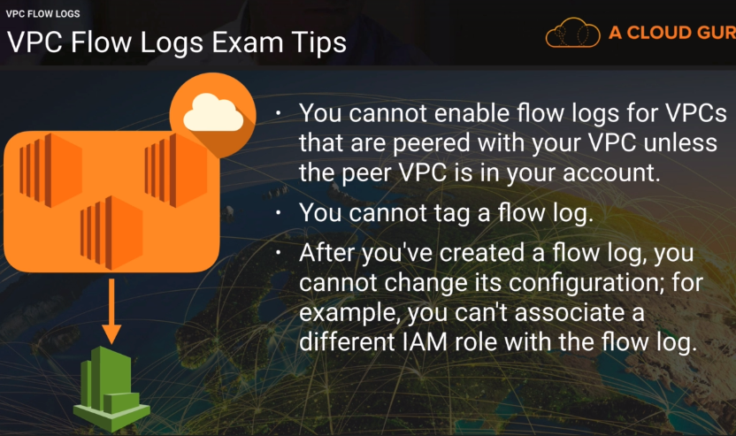

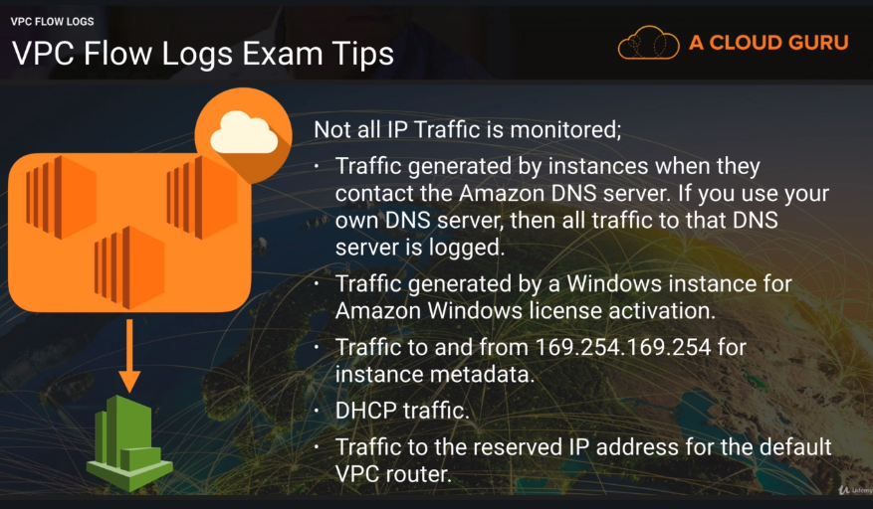

NAT and Bastion(Jump Box) Servers-

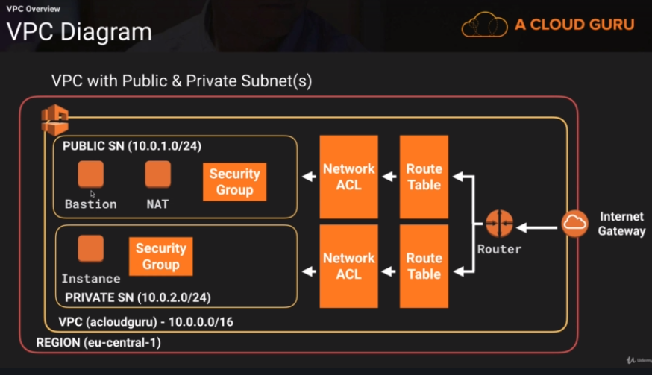

Bastian server - Acts as a jump boxes to connect to all the private servers in the VPC.

Nat Instances are always behind security group.

(Nat gateways are SG independent)

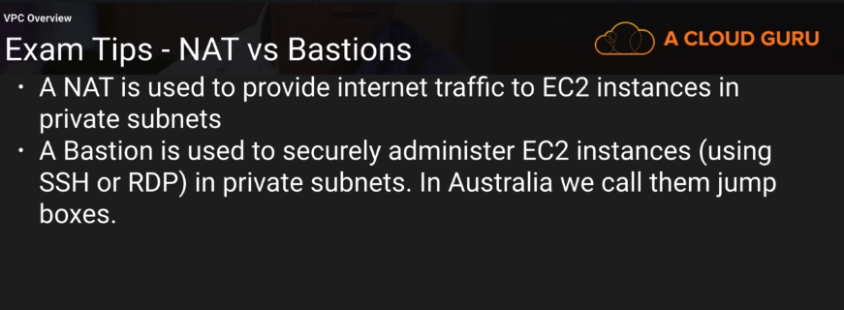

VPC Endpoints-

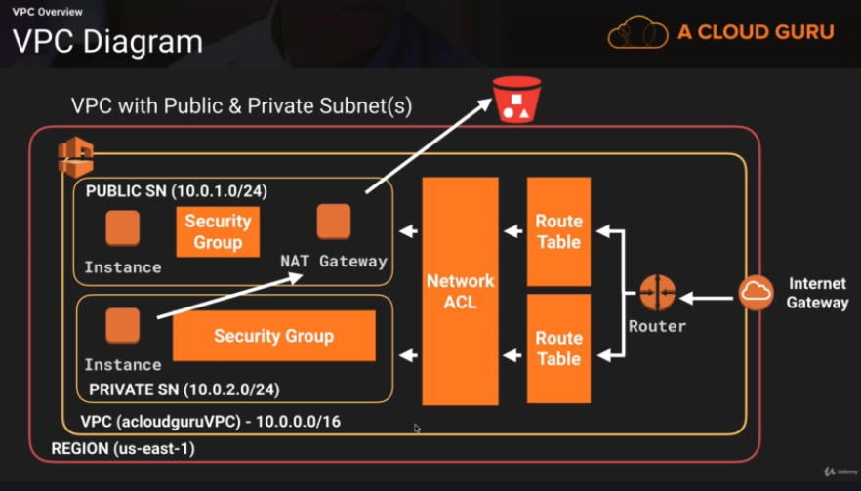

Lab-

Go to TAM service and create a Role.

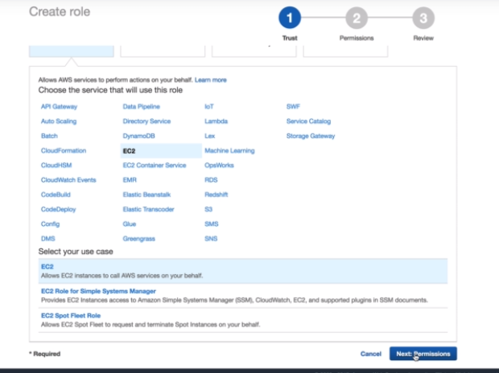

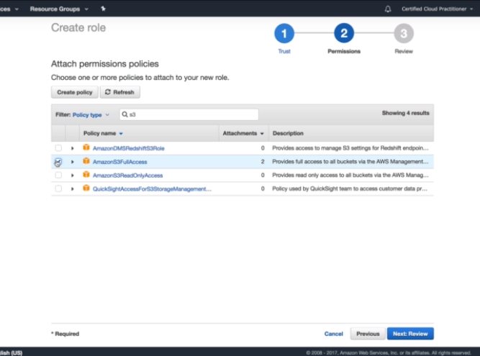

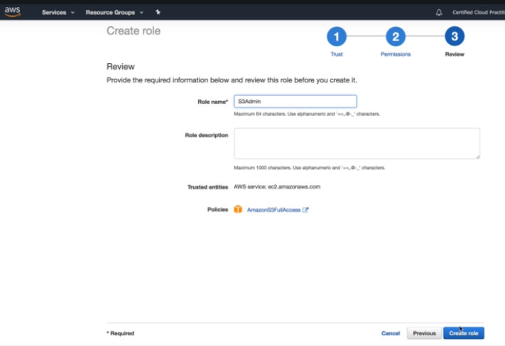

Go to EC2 and attach the created Role to the private Instance.

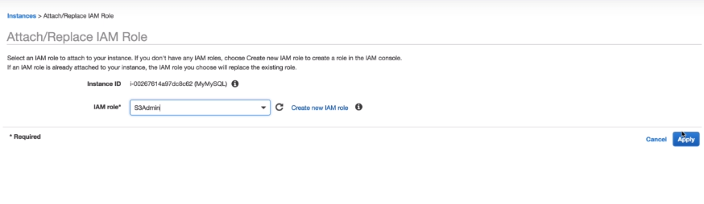

Go to the VPC service and associate both the to the default NACL.

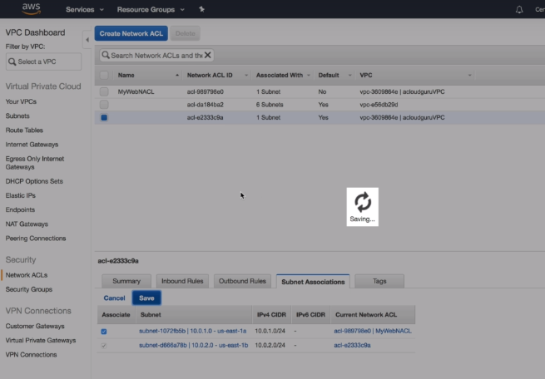

Log in to your public instance and from there ssh to your private network.

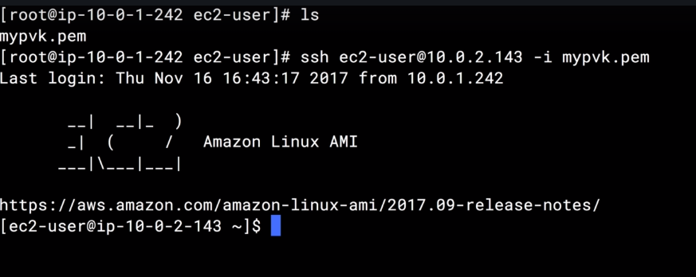

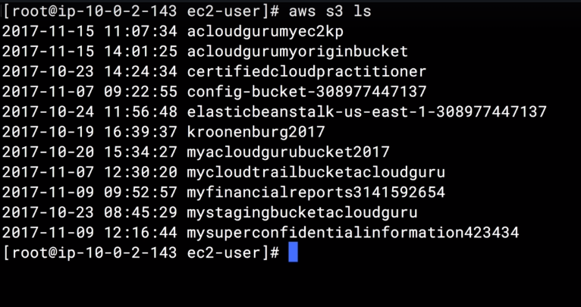

If you shut down the NAT Gateway, this will not work as this is going through the internet. Lets try it.

For this go to the route table and remove the route of NAT gateway from it.

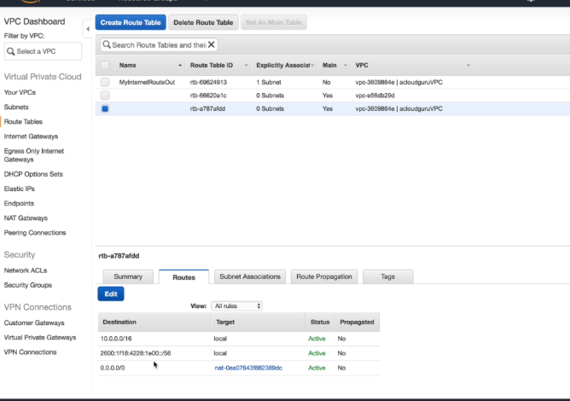

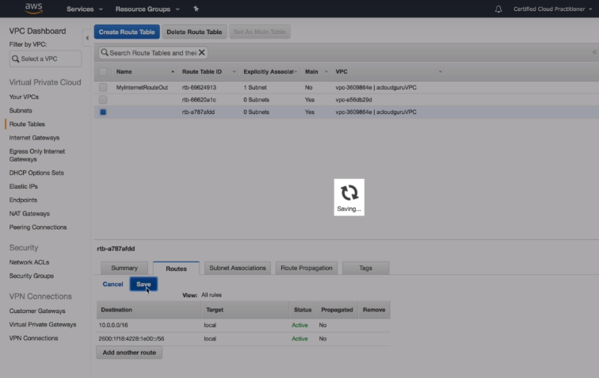

Now, there will be no result for the below,

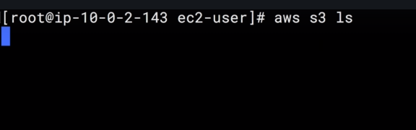

To overcome this dependency on the internet via NAT gateway, we will create VPC endpoints.

Select the S3 gateway,

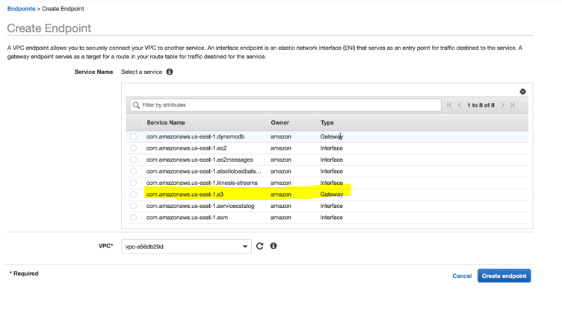

Select your VPC,

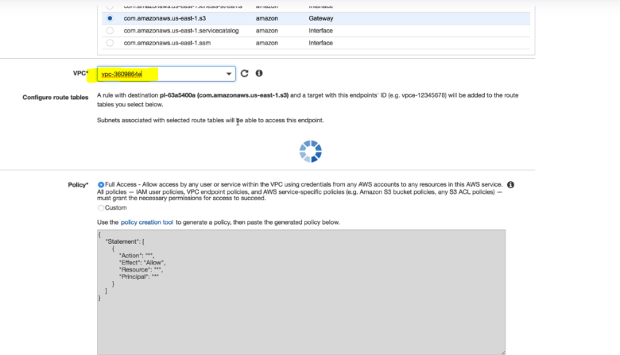

Associate to the main route table,

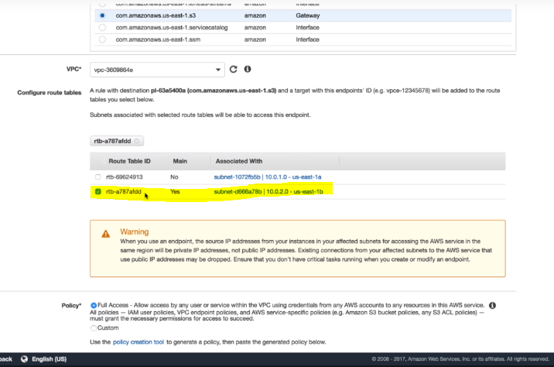

Create the endpoint

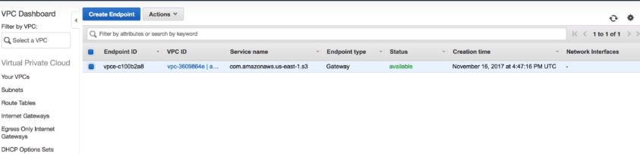

Go to the route table see the routes for the default table, VPC endpoints routes will be there.

